Database Project CS260

Title : TPC Portal

Names : R.Eshwar

S.Deshik

RollNo : 2101AI25

2101AI32



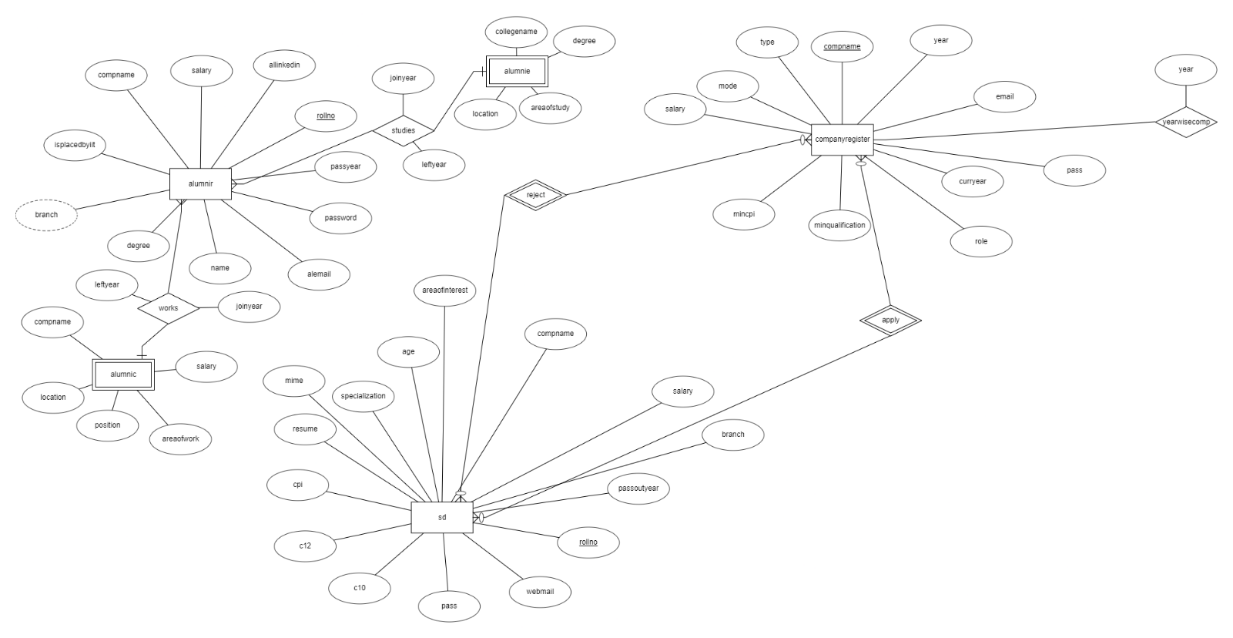

Database

List of tables created

1. sd [ Table to store student data ]

List of attributes

name – Name of the student

rollno – Roll No of the student

webmail – Email of the student

c10 – Class X marks of student

c12 – Class XII marks of student

special- Specilization of Student

age – Age of Student

aoi – Area of interest

branch – Branch in College

passoutyear – Passing out year expected

compname – To be updated after the placement is done automatically

salary – salary offered by the compname where he got placed

resume – blob which stores resume

mime – application/pdf

2.companyregister[Table to store Company related information]

List of Attributes

compname – Name of the Company

email – Email of the Company

Eligibilities of Company

minqualification -

mincpi –

salary- Salary offered

mode- Online or Offline

type – Interview or Written

role – role offered by company

3.alumnir[Table to store basic information of Alumni]

List of attributes used

rollno - rollno of alumni when they are in iitp which is primary key

name – Name of student

passyear – Passed Out Year of alumni

alcpi – CPI in iitp

degree- Degree enrolled in iitp

branch – Branch enrolled in iitp

alemail – alumni working email

allinkedin – alumni linkedin details

isplacedbyiit – question from tpc if yes he enters the following attributes

compname – foreign key of company register

salary- salary offered in their year as this is dynamic no foreign key constraint

4.alumnic[Table to store all alumni professional jobs information]

List of attributes as alumni can join other companies apart from companies which come to iitp

rollno – foreign key from alumnir

compname – Name of company

salary – Salary offered by the company

joinyear – date of joining

leftyear – date of leaving

areaofwork – Software development , Business Management , Testing , QA

position – Level in company

location - location of working

5.alumnie[Table to store all alumni educational journey information]

List of attributes as alumni can join other colleges apart from iitp

rollno – foreign key from alumnir

collegename – Name of college

degree – degree enrolled

joinyear – date of joining

leftyear – date of leaving

areaofstudy –

location - location of college

6.apply[Table to keep records of applications from students to companies]

rollno and compname are the attributes this is page is very dynamic

as applications go on rejected or accepted

7.result[Table to keep records of applications being rejected or accepted by company]

Categorized into reject and accept

Again rollno and compname are the attributes



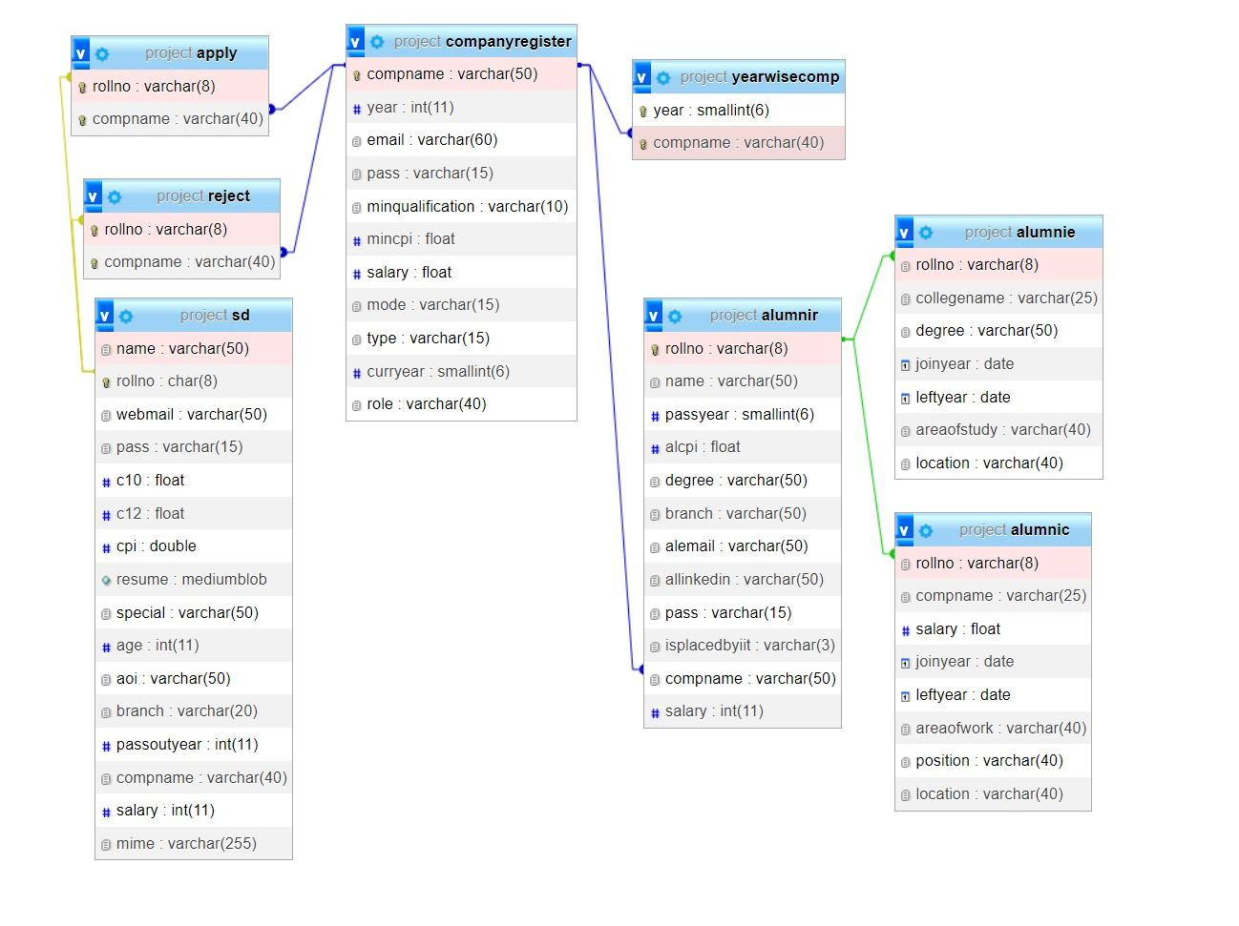

Foreign Keys

1.rollno is foreign key in tables apply reject which has references from table sd where rollno is the primary key.For a company to reject or accept a students application student must be present in database.

2. compname is foreign key in tables apply reject which has references from table companyregister where compname is the primary key.For a company to reject or accept a students application student must be present in database.

3.alumnic and alumnie draws rollno as foreign key from alumnir

where rollno is primary key in alumnir.